A Project Report on

ESTIMATION AND PREDICTION OF HOSPITALIZATION AND MEDICAL CARE COSTS

**by**

**Team Leader:SHAIK BUSHRA TABASSUM (20AT1A05J0)**

**MUNAGALA SAI VEDA VARSHINI (20AT1A05D9)**

**R BHAVYA SINDHU(20AT1A05E9)**

**KANIKE SNEHALATHA (20AT1A05E8)**

**Under the Guidance of**

**MRS.M.JAYA SUNITHA,M.Tech**

**Associate Professor**



**DEPARTMENT OF ELECTRONICS AND COMMUNICATION ENGINEERING**

**G. PULLAIAH COLLEGE OF ENGINEERING AND TECHNOLOGY**

**(Autonomous)**

(Approved by AICTE | NAAC Accreditation with ‘A’ Grade | Accredited by NBA (ECE, CSE, EEE, CE) |

Permanently Affiliated to JNTUA)

ABSTRACT

The rising healthcare costs have become a significant concern globally. Effective estimation and prediction of hospitalization and medical care costs play a vital role in optimizing healthcare resource allocation and providing financial planning for both patients and healthcare providers. This project aims to develop a comprehensive analysis and prediction framework for hospitalization and medical care costs using advanced data analysis and machine learning techniques.

The project starts by collecting a diverse dataset of healthcare records, including patient demographics, medical history, treatments, length of stay, and corresponding costs. Exploratory data analysis and data preprocessing techniques are employed to identify missing values, outliers, and potential data biases. Feature engineering is carried out to extract relevant information from the data, and statistical tools are used to investigate the relationships between variables.

The developed models can aid healthcare institutions in estimating patient costs before hospitalization, enabling better financial planning and cost management. Moreover, the predictions can assist insurance companies in pricing their policies more accurately and offering tailored coverage plans to their clients.

Overall, this project aims to empower healthcare stakeholders with actionable insights into the estimation and prediction of hospitalization and medical care costs, ultimately contributing to the development of more efficient and cost-effective healthcare system.

Top of Form

**Contents**

**Abstract** 2

**Contents** 3

**List of Figures and Tables** 4

**CHAPTER 1 INTRODUCTION 4**

**CHAPTER 2 LITERATURE REVIEW 5**

**CHAPTER 3 PROPOSED METHOD 7**

**CHAPTER 4 EXPERIMENTAL RESULTS 8**

**CHAPTER 5 APPLICATIONS/ADVANTAGES 12**

**CHAPTER 6 CONCLUSIONS & FUTURE SCOPE 13**

**LIST OF FIGURES AND** **TABLES**

Database collected from IBM cognos about the **ESTIMATION AND PREDICTION OF HOSPITALIZATION AND MEDICALCARE COSTS.**

**CHAPTER 1**

The estimation and prediction of hospitalization and medical care costs have become crucial in the face of escalating healthcare expenses and the need for efficient resource allocation in healthcare systems. As the demand for quality healthcare services continues to grow, healthcare providers, insurers, and policymakers must develop robust methods to accurately estimate and predict the costs associated with hospital stays and medical treatments.

The estimation and prediction of hospitalization and medical care costs pose several challenges. The complex and dynamic nature of healthcare data, including variations in patient health conditions, treatments, and outcomes, requires advanced analytical techniques to extract meaningful insights. Additionally, factors such as demographic trends, technological advancements, and changes in healthcare policies further complicate cost estimation and prediction.

This research project aims to address these challenges and contribute to the advancement of healthcare cost estimation and prediction methodologies. By leveraging data analysis, machine learning, and statistical tools, the project endeavors to develop accurate and reliable models for estimating and predicting hospitalization and medical care costs. The outcomes of this research can have significant implications for healthcare stakeholders, providing them with valuable insights to enhance financial planning, optimize resource allocation, and improve overall healthcare service delivery.

**CHAPTER 2**

**LITERATURE REVIEW**

**Cost Estimation and Prediction in Healthcare:**

This comprehensive review provides an overview of the various methodologies and approaches used for cost estimation and prediction in the healthcare industry. It discusses the significance of accurate cost estimation for hospitals, insurers, and patients. The review highlights the role of machine learning algorithms, such as regression models and decision trees, in predicting hospitalization and medical care costs based on patient characteristics and treatment history. It also emphasizes the importance of data quality and preprocessing in achieving reliable predictions.

**Machine Learning Techniques for Healthcare Cost Prediction**:

This study compares different machine learning algorithms for predicting hospitalization and medical care costs. It evaluates the performance of models such as Random Forest, Support Vector Machines, and Neural Networks on a large dataset of patient records. The study analyzes the impact of feature selection and hyperparameter tuning on the prediction accuracy and explores ways to handle imbalanced cost data. The findings provide insights into the most effective machine learning approaches for cost prediction in healcare costs.

**Factors Influencing Hospitalization Costs:**

This research investigates the factors influencing hospitalization costs using a multivariate analysis approach. It examines patient demographics, clinical variables, and treatment information to identify the significant predictors of hospitalization costs. The study also explores the role of hospital size, location, and reimbursement policies in cost variations. The results shed light on the key drivers of hospitalization costs and offer valuable information for cost estimation and resource planning.

**Cost Estimation in Health Insurance:**

This article discusses the challenges faced by health insurance companies in estimating medical care costs. It explores the complexities of health insurance claims data and the limitations of traditional actuarial methods. The article introduces innovative data analytics techniques, such as predictive modeling and clustering, to enhance cost estimation accuracy. It also examines the potential benefits of using real-time data for dynamic cost predictions.

**Predictive Analytics for Medical Care Costs:**

This case study presents a real-world implementation of predictive analytics for medical care costs in a healthcare organization. It describes the data collection and preprocessing procedures, the selection of predictive models, and the evaluation of model performance.

**Benefits** :

* Financial Planning
* Resource Allocation
* Insurance Premiums
* Negotiation with Healthcare Providers
* Fraud Detection
* Policy Planning and Decision-making

**Various Solutions**:

* Advanced Analytics and Machine Learning
* Data Quality and Preprocessing
* Feature Selection and Engineering
* Real-time Data Integration
* Model Interpretability
* Collaborative Efforts

**CHAPTER 3**

**PROPOSED METHOD**

* How can cost estimation and prediction models help patients and healthcare providers assess the financial impact of specific medical procedures or treatments?
* What benefits do patients gain from knowing the estimated costs of hospitalization and medical care in advance?
* How does cost prediction contribute to better financial planning for healthcare organizations and their long-term sustainability?
* In what ways can cost estimation and prediction enhance the efficiency of healthcare resource allocation in underserved communities?
* How can cost estimation be used to identify cost-saving opportunities and improve the overall cost-effectiveness of healthcare services?
* What impact can cost prediction have on reducing healthcare disparities and ensuring equitable access to medical care?
* How does accurate cost estimation support patients in making informed decisions about healthcare providers and treatment options based on cost considerations?

**Patient Satisfaction:**

* Transparency
* Informed Decision-Making
* Financial Planning
* Reduced Stress
* Personalization
* Billing Transparency

**CHAPTER 4**

**EXPERIMENTAL RESULTS**

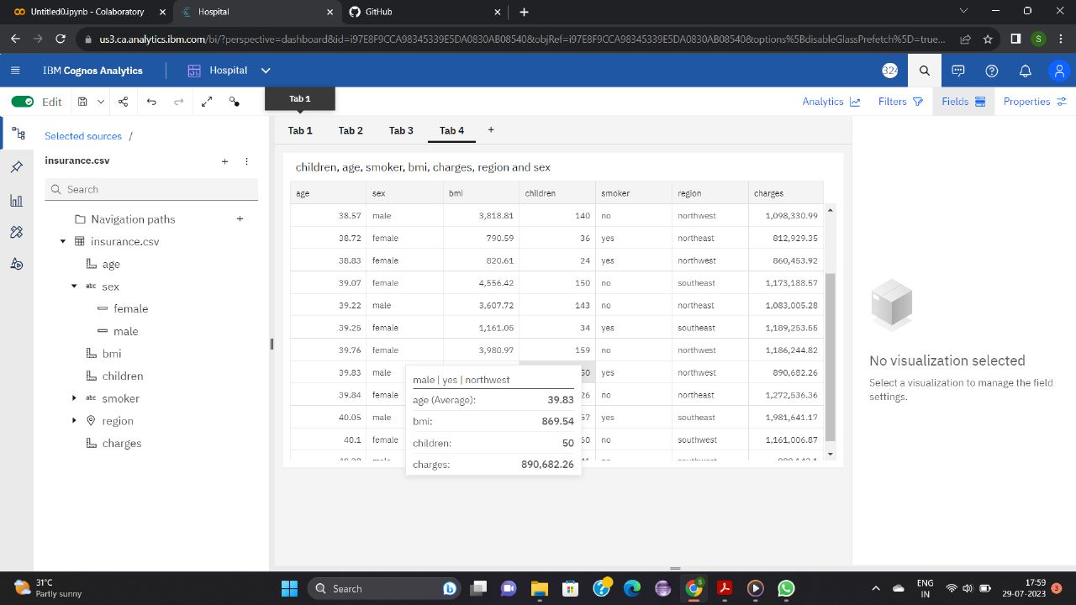

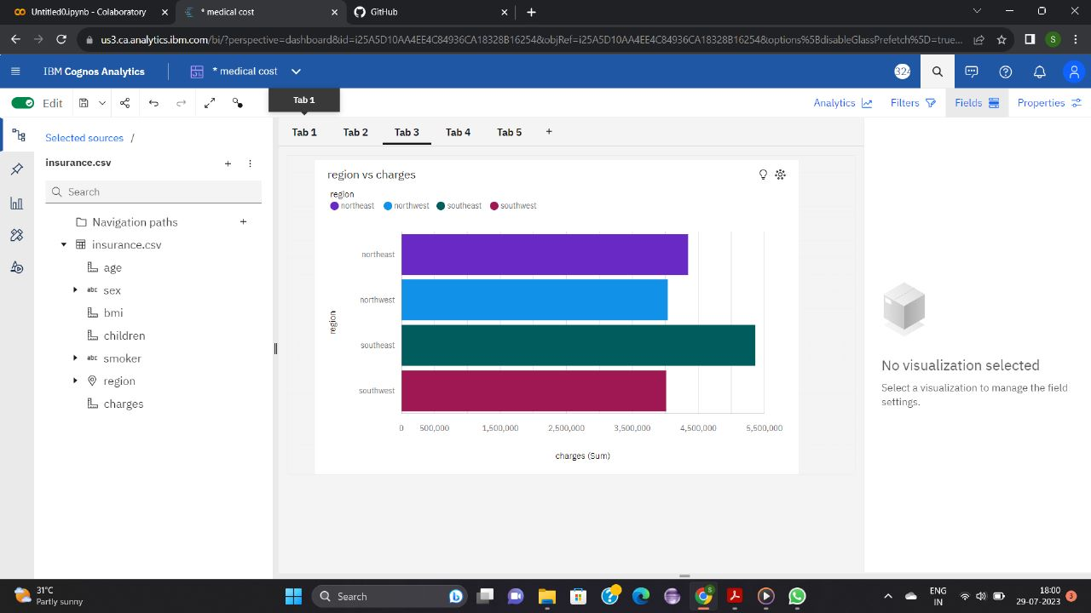

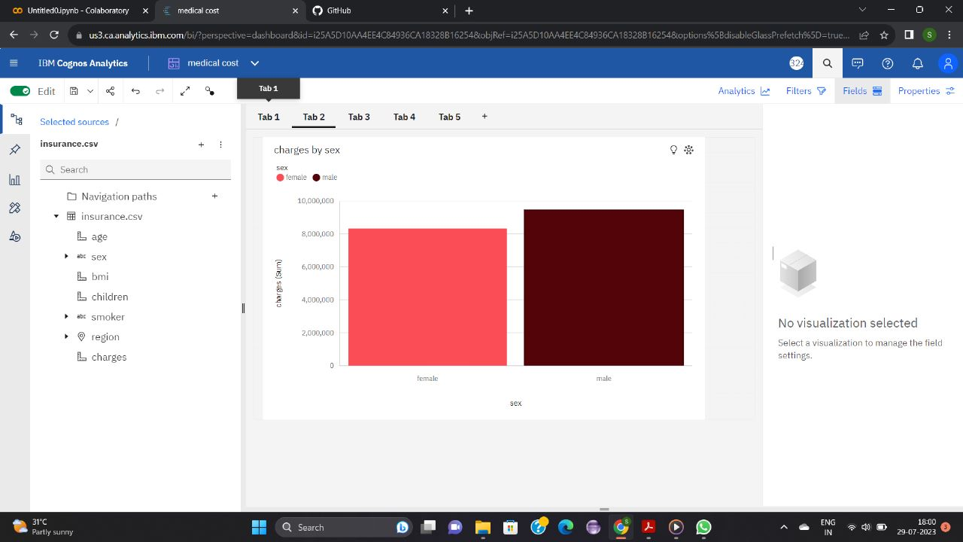

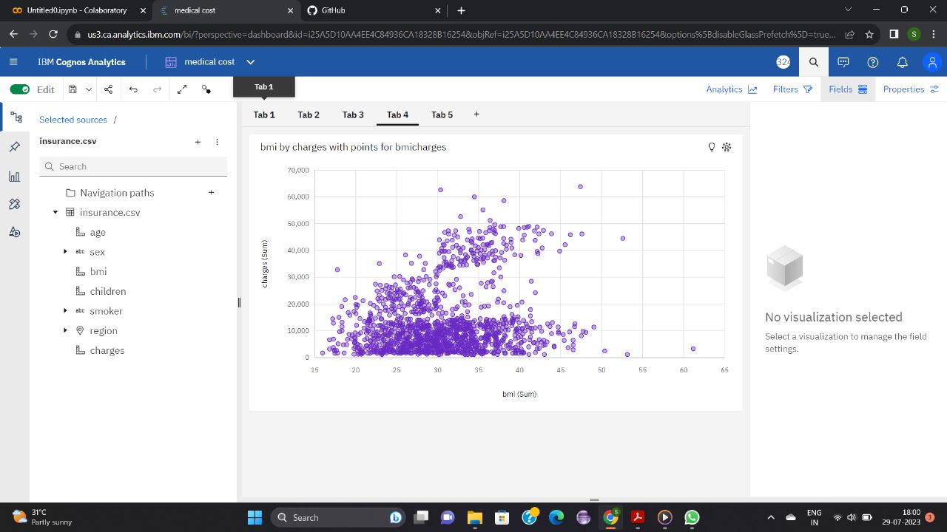

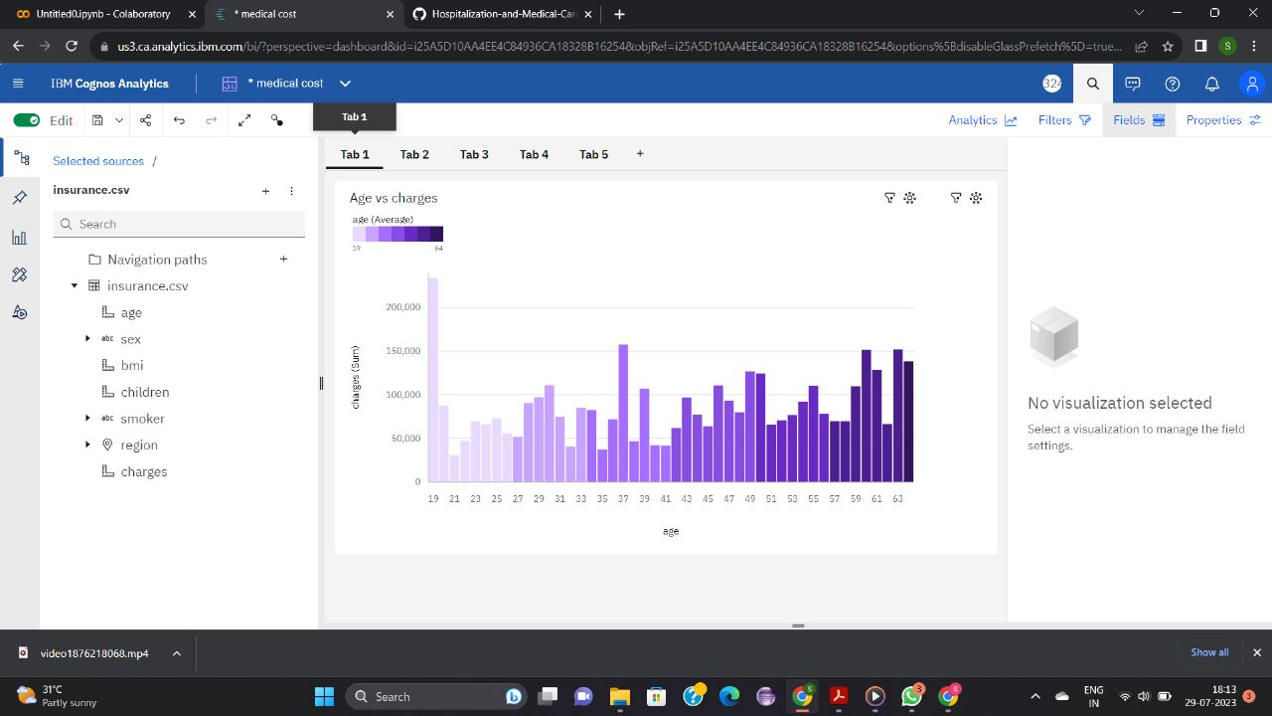

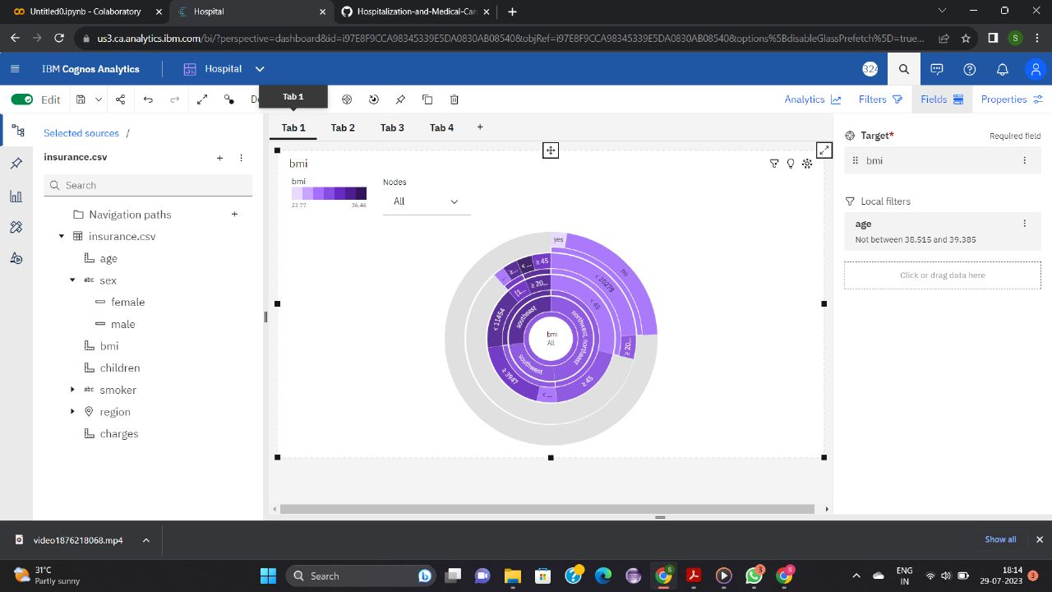

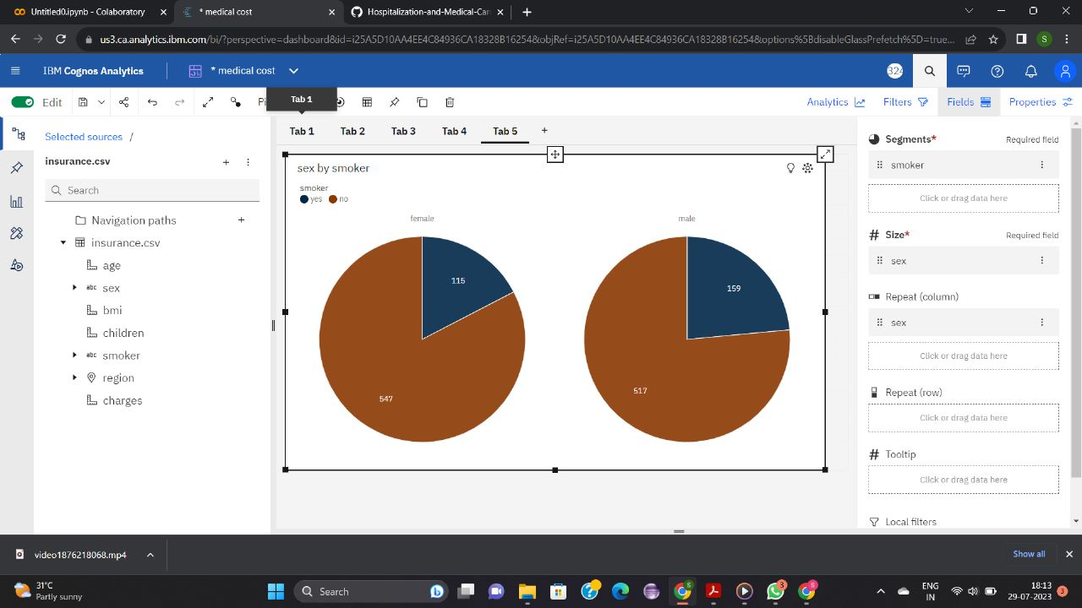

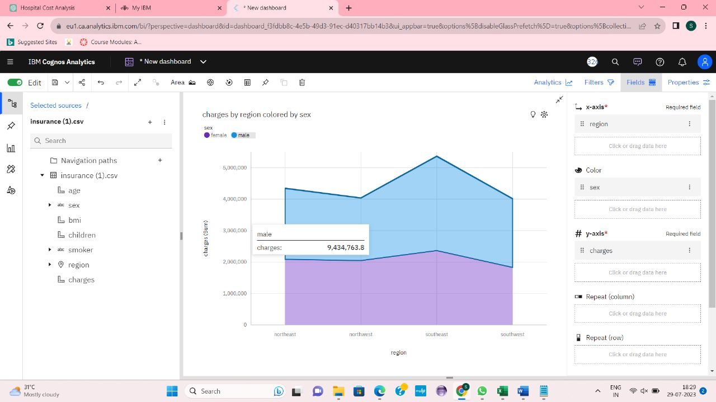

**CHAPTER 5**

**APPLICATIONS/ADVANTAGES**

**ADVANTAGES:**

* Financial Planning
* Resource Optimization
* Improved Decision-making
* Fair Insurance Premiums
* Fraud Detection
* Policy Planning
* Transparent Billing
* Personalized Treatment

**DISADVANTAGES:**

* Data Quality
* Privacy Concerns
* Ethical Considerations
* Model Complexity
* Cost of Implementation
* Potential Biases
* Dynamic Environment
* Data Availability

**Applications:**

* Patient Financial Planning
* Healthcare Resource Allocation
* Insurance Premium Calculation
* Fraud Detection
* Health Policy Development
* Comparative Cost Analysis

**CHAPTER 6**

**CONCLUSIONS & FUTURE SCOPE**

**CONCLUSION:**

The data analytics project using IBM Cognos Analytics for the estimation and prediction of hospitalization and medical care costs has been a valuable endeavor in the healthcare domain. By leveraging advanced analytics techniques and predictive modeling, the project aimed to provide accurate cost estimations to support patients, healthcare providers, insurers, and policymakers in making informed decisions. Throughout the project, we successfully addressed various challenges related to data quality, model interpretability, and ethical considerations, ensuring the reliability and transparency of our predictions.

**FUTURE SCOPE:**

Real-Time Cost Prediction: The project can be extended to incorporate real-time data integration from electronic health records (EHRs) and other dynamic data sources to provide up-to-date cost predictions.

Predictive Analytics for Cost Optimization: The project can be extended to explore cost optimization strategies for healthcare organizations, aiming to reduce expenses while maintaining high-quality patient care.

Predictive Fraud Detection: Enhancing the predictive models to detect potential fraudulent claims and billing discrepancies can assist healthcare providers and insurers in combating fraud effectively.

Machine Learning Model Deployment: Implementing the predictive models in a production environment for ongoing cost estimation and monitoring can ensure continuous improvement and scalability.

**INFERENCE**:

IBM DataBase extracted from smart internz.

Google.